An Obligation of Honor
Pima-Maricopa Irrigation Project Education Initiative

Restoring water to ensure the
continuity of the Akimel O’otham
and Pee Posh tradition of agriculture

Re

Part 13

In 1898, the United States Congress appropriated $20,000 for the US Geological Survey (USGS) to evaluate two potential dam sites for the benefit of the Community. One of these sites was on Queen Creek and the other on the Gila River at the Buttes, 14 miles east of Florence. This appropriation was important because it showed the United States recognized it had an obligation to restore water for the use and benefit of the Gila River Indian Community, which has “unquestioned legal rights … to a large quantity of the waters of the Gila River.” The question was how to do this.
An earlier USGS study, for example, indicated the United States was unwilling to restore the water taken from the Community but then used by non-Indians because to do so “would be the height of injustice to deprive the present occupants of the water.” Even if it did restore the water, allowing the natural current of the Gila River to flow across the Community would, in the eyes of hydrologist Frederick Newell, be a waste of water as it seeped into the desert riverbed and evaporated in the dry desert heat. Newell’s companion, Arthur Davis, believed that “several acres well-tilled by white men [upstream] would be destroyed for the benefit of one acre poorly worked by the Indians [downstream].”
Without a natural flow of water from the Gila River, the only alternatives appeared to be constructing artesian wells, submerged dams (which pushed the underground flow of the river to the surface), pump stations to bring groundwater to the surface, or canals to divert water from the Salt River. There was also the option of constructing a dam upstream to store and deliver a sufficient quantity and quality of water to the Community. While the immediate prospects of artesian wells, submerged dams and groundwater pumping were not good, and Salt River water diversions were costly, there were good prospects for constructing a dam upstream on the Gila River.
Congress authorized the USGS to evaluate the Buttes and a site on Queen Creek. Before the study was completed, five sites had been reviewed, three of which were “discovered” during the evaluation of the Gila River watershed. But, before site evaluation occurred, Joseph Lippincott of the USGS sought to determine the average flow of the river. At the Buttes, he calculated this flow at 469,093 acre-feet per year.
The first site evaluated was on Queen Creek, a creek that “in ordinary years” lost “itself in the desert” north of the Community. This site was quickly rejected due to insufficient water flow, which was estimated at about 12,000 acre-feet per year. In 1898, the Community required more than 30,000 acre-feet of water per year based on 15,000 irrigated acres of land. A Senate report of 1899, however, acknowledged that most of the 357,120 acres of the reservation was “arable and irrigable land if water could be had for it.”
The second site was on the Gila River, 25 miles above the reservation at a place called the Buttes. The prospects of a dam at the Buttes were not questioned, but consulting engineering James Schuyler did raise the question of “whether it is feasible, desirable, or proper to construct a dam and reservoir in the immediate channel of the Gila of so small capacity as 40,000 acre-feet [to benefit the Gila River Indian Community] … when the maximum flow is more than fifteen times the suggested reservoir capacity.”
Schuyler recommended that a large storage reservoir be built. This would allow the Community to receive water and afford the opportunity for “reclaiming a very large section of the arid public domain” south and east of the reservation. “It would be quite possible for the United States Government to pay for the entire outlay and provide homes for a large farming population, adding immeasurably to the wealth and population of the territory.” An “act of justice” to the Community would be of greater “public utility and advantage.”
The Buttes, however, was not recommended as the site for a storage dam. The “extreme height of the dam required [293’ tall]” and the “rotten nature of the bed rock” were both undesirable for the construction of a dam storing 174,000 acre-feet of water. And this capacity was but half of the estimated annual flow of the river.
If the Buttes were selected as the site for the dam, water would have been released at the dam and traveled 25 miles through the Gila River. Such a proposition, Schuyler argued, “would be wasteful and improvident” because the loss of water “by absorption is very great” in the sandy bed of the Gila. To reduce seepage losses, Schuyler recommended a “new and permanent headworks” for the canal and a general enlargement and extension of the Florence Canal with laterals extending to the reservation. Clearly, Schuyler wished to see a storage dam that would supply the Community and the large fertile valleys south and east of the reservation with water.
To construct such a dam would take three years, cost more than $2.6 million and store a maximum of 174,040 acre-feet of water on a lake covering 3,149 acres. Two-thirds of the average flow of water would be “lost” down river. To raise the dam an additional 40 feet (with 353,000 acre-feet of water storage) was “not deemed feasible” at this site. Because of the high degree of silting in the river, the dam would be filled with silt in 18 years.
The remaining sites were discovered in the ensuing investigation of the Gila River. The first of these sites (third overall) was below the confluence of the San Pedro and Gila rivers. It was known as the Riverside site. A dam the size of the one proposed for the Buttes would have stored “over 650,000 acre-feet” of water at Riverside and would take “over one year” to fill.
But the Riverside site had many disadvantages, one of which was a large number of copper mining claims in the Riverside basin. In addition, the Ray Copper mines had recently constructed a railway along the river. In order to build the dam, land and mining claims would have to be purchased. Nonetheless, even with right-of-way and land claim purchases and a new diversion dam at the head of the Florence Canal, the Riverside dam could have been constructed for $1,989,605.
Another site considered was Guthrie Reservoir. This site was 13 miles below the eastern Arizona town of Duncan. Prospects for a 140’ tall dam were limited, as the major tributaries of the Gila River (the San Carlos, Gila Bonita, San Francisco and San Pedro rivers) all joined the Gila down stream from the dam. A maximum of 255,800 acre-feet of water could have been stored at the Guthrie site. But it was considered too far away from the main agricultural lands to have been efficient.
The last of the three new sites was San Carlos. This site was located at the mouth of the San Carlos River where it empties into the Gila River at the far western boundary of the San Carlos Apache Reservation. The San Carlos site was 60 miles upstream of the Buttes and was the leading edge of a 31-mile long box canyon. Solid bedrock would allow the dam to be firmly anchored and provide adequate construction material. A potential 300’ tall dam could store nearly 700,000 acre-feet of water. The site, however, would cover some 4,405 irrigable acres of Apache land with water. In addition, dozens of Apaches and the old San Carlos Indian Agency would have to be relocated. Relocation of five miles of railroad line would also have to occur. The cost of a 230’ tall storage dam and reservoir capable of storing 241,396 acre-feet of water was estimated at $1,038,926.
The primary purpose behind the USGS study was to identify storage sites to impound and deliver water to the Gila River Indian Community, the soil of which was “exceedingly fertile.” Without water, the reservation would remain “a desert and have no value.” But the study also opened the door to building a larger storage site that could impound water to develop more than 100,000 acres of non-Indian land. “The greatest economy to the Government,” Lippincott argued, “lies in the construction of a large reservoir.” By building a large reservoir the United States could provide water to the Akimel O’otham and Pee Posh “without charging them for it, and sell the remainder” to non-Indian farmers. “Being the owner of more land under the [proposed reservoir and] canal than can ever be watered by it,” the government would be able to “control the appropriation of the [land] values” of the area south and east of the reservation.
The USGS concluded that it was an “imperative obligation of honor that [the water supply of the Gila River Indian Community] … be restored to them, and the only practical means of this restoration is by storage on the Gila River.” But, while the United States recognized its obligation to the Community it also began looking at ways to provide water to new non-Indian farms in the Florence-Casa Grande valleys. Nearly 450,000 acres of public and private land in the valleys south and east of the reservation could potentially benefit from water impounded for the Gila River Indian Community.

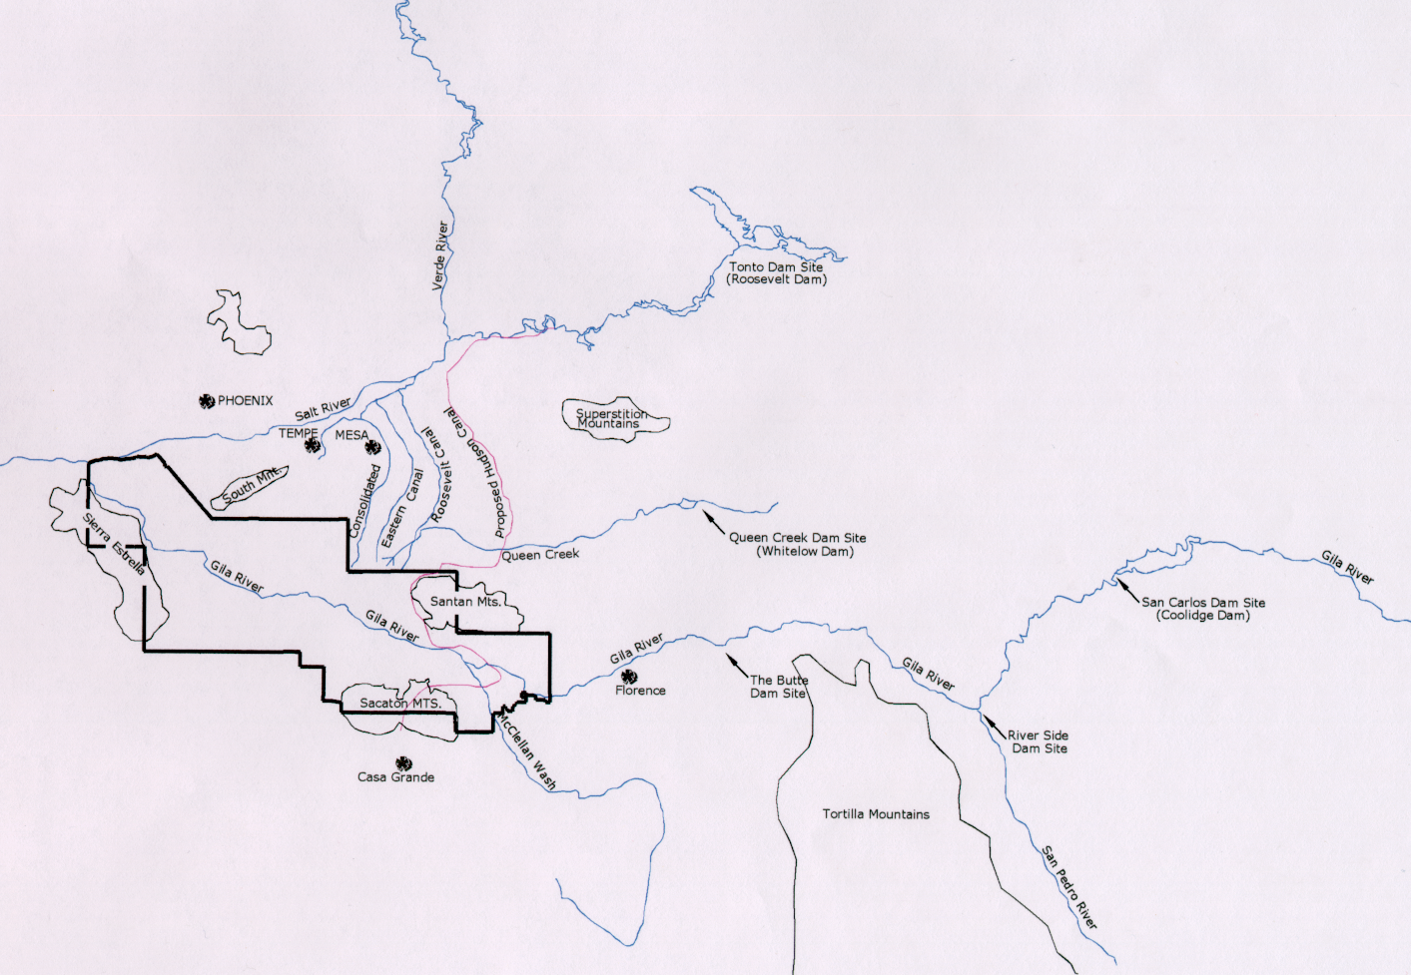
Teacher Plan for “An Obligation of Honor”

Objectives

Students will be able to:

- Identify the potential reservoir sites that would provide water for the Gila River Indian Community.

- Analyze the USGS argument for building a large reservoir to provide water for both the Gila River Indian Community and non-Indian farmers south and east of the reservation.

Terms to know and understand

- Hydrologist
- Seepage
- Evaporation
- Irrigable
- Acre-foot
- Honor
Critical Thinking:

- The 1899 USGS study included a recommendation to build a much
larger storage reservoir than the Akimel O’otham and Pee Posh needed
at the time. But, the recommendation was not to store water for future
Akimel O’otham and Pee Posh It was to store additional water for
non-Indian farms. These farms would be built south and east of the Community. In effect, the USGS recommended building a “joint-use” irrigation project. Was this a wise decision? Explain.
Activities:

- Use the chart below and have students calculate the cost per acre-foot of water based on the storage capacities and project costs shown. Which one would store the greatest volume of water? Which has the lowest cost per acre-foot (divide cost by storage capacity)? Ask students if they know which one the US Government eventually selected as the storage reservoir site.
Cost Per Acre-foot of Water Stored
Location Storage Capacity (in acre-feet) Cost $ Per Acre-foot
The Buttes 174,040 $2,643,668 _____________
Riverside 221,128 $1,989,605 _____________
San Carlos 241,396 $1,038,926 _____________
- Explain to students that water was to be free to the Gila River Indian Community for several reasons. First, the Community’s water supply was taken from them and the people were starving. Restoring water was, as one official stated, “An obligation of [American] honor.” Second, the Community’s land was (is) “trust land,” meaning it is owned by the Community but title is held by the United States. Trust land cannot be used as collateral and cannot be mortgaged. That was one of the reasons the USGS recommended a joint-use reservoir. By providing water to a large area of non-reservation public domain, the sale of the land and the rights to the water could be used to pay for the entire storage dam.
About P-MIP

The Pima-Maricopa Irrigation Project is authorized by the Gila River Indian Community to construct all irrigation systems for the Community. When fully completed, P-MIP will provide irrigation for up to 146,330 acres of farmland. P-MIP is dedicated to three long-range goals:
- Restoring water to the Akimel O’otham and Pee Posh.
- Putting Akimel O’otham and Pee Posh rights to the use of water to beneficial use.
- Demonstrating and exercising sound management to ensure continuity of the Community’s traditional economy of agriculture.

